*Big Data and Hadoop Development*

Project 1.2

**A C A D G I L D Page 1**

*Big Data and Hadoop Development*

*Project 2.1- State-Wise Development Analysis In India*

**Table of Contents**

1. Executive Summary ............................................................................................................................... 3

1.1 Project Overview ........................................................................................................................... 3

1.2 Purpose and Scope of this Specification ....................................................................................... 3

2. Product/Service Description ................................................................................................................. 3

2.1 Assumptions .................................................................................................................................. 3

2.2 Constraints .................................................................................................................................... 3

3. Requirements ........................................................................................................................................ 4

4. Problem statement ............................................................................................................................... 5

**A C A D G I L D Page 2**

*Big Data and Hadoop Development*

**1. Executive Summary**

**1.1 Project Overview**

To develop the System to analyze the log data (In XML format) of government progress of

various development activities.

**1.2 Purpose and Scope of this Specification**

The purpose of this project is to capture the data for analyzing the progress of various

activities.

**In scope**

The following requirement will be addressed in phase 1 of Project:

• Developing system to handle the incoming log feed and store the information in Hadoop

Cluster (Flume)

• Analyze the data and understand the progress

• Store the results in Hbase/RDBMS

Out of scope

We can use this data and visualization and get more insights

**2. Product/Service Description**

**2.1 Assumptions**

Log will be generated in XML format and stored in a server

**2.2 Constraints**

Describe any item that will constrain the design options, including

• This system may not be used for searching for now. But it will be used for analysis and

saving the relevant information as of now

• System will be using Hbase as a database

**A C A D G I L D Page 3**

*Big Data and Hadoop Development*

**3. Requirements**

• The FLUME job which will format the data and place the data to HDFS

• Pig/MapReduce job for parsing the XML data.

• Create Pig scripts/MapReduce jobs to analyze the data

• Create the Sqoop job to store the data in database

**Priority Definitions**

The following definitions are intended as a guideline to prioritize requirements.

• Priority 1 – Create FLUME job for fetching log files from spool directory the data

• Priority 2 – MapReduce/pig job to preprocess

**Download the dataset using the below link:**

**Link:**

https://drive.google.com/file/d/0Bxr27gVaXO5sUjd2RWFQS3hQQUE/view?usp=sharing

**Refer the below steps to understand the actual steps to create the**

**above project.**

**Step 1:**

Copy dataset from local file system to HDFS using flume.

Note: use the conf file by downloading from below link.

Click here to download

**Command:**

flume-agent agent –n agent1 –c conf –f <path to filecopy.conf>

**A C A D G I L D Page 4**

*Big Data and Hadoop Development*

**Step 2:**

Input file is in the XML format use Map reduce or pig to parse the data and get the results for

the below problem statements.

**4. Problem statement**

1. Find out the districts who achieved 100 percent objective in BPL cards

Export the results to mysql using sqoop

2. Write a Pig UDF to filter the districts which have reached 80% of objectives of BPL cards.

Export the results to MySQL using Sqoop.

**A C A D G I L D**

Step 1: Copy dataset from local file system to HDFS using flume. Note: use the conf file by downloading from below link.

Command:

flume-agent agent –n agent1 –c conf –f Big Data and Hadoop Development

Step 2: Input file is in the XML format use Map reduce or pig to parse the data and get the results for the below problem statements.

**Problem statement :**

1. Find out the districts who achieved 100 percent objective in BPL cards

Export the results to mysql using sqoop

2. Write a Pig UDF to filter the districts which have reached 80% of objectives of BPL cards. Export the results to MySQL using Sqoop.

**First, creating a directory named as flume_import.**

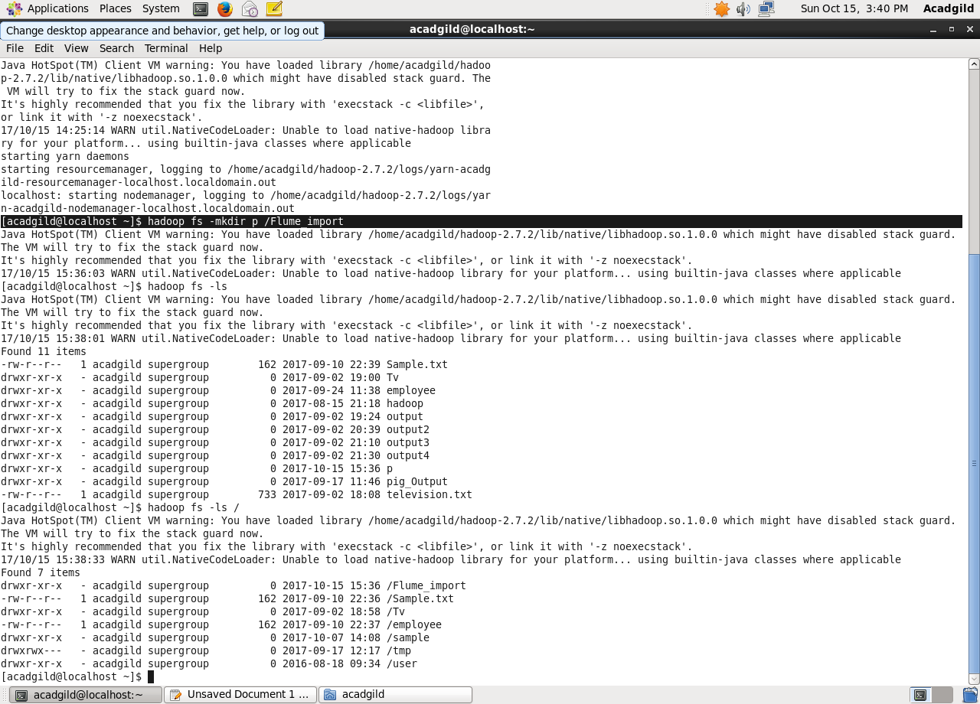

Copying dataset from local file system to HDFS using flume by using the below conf file.

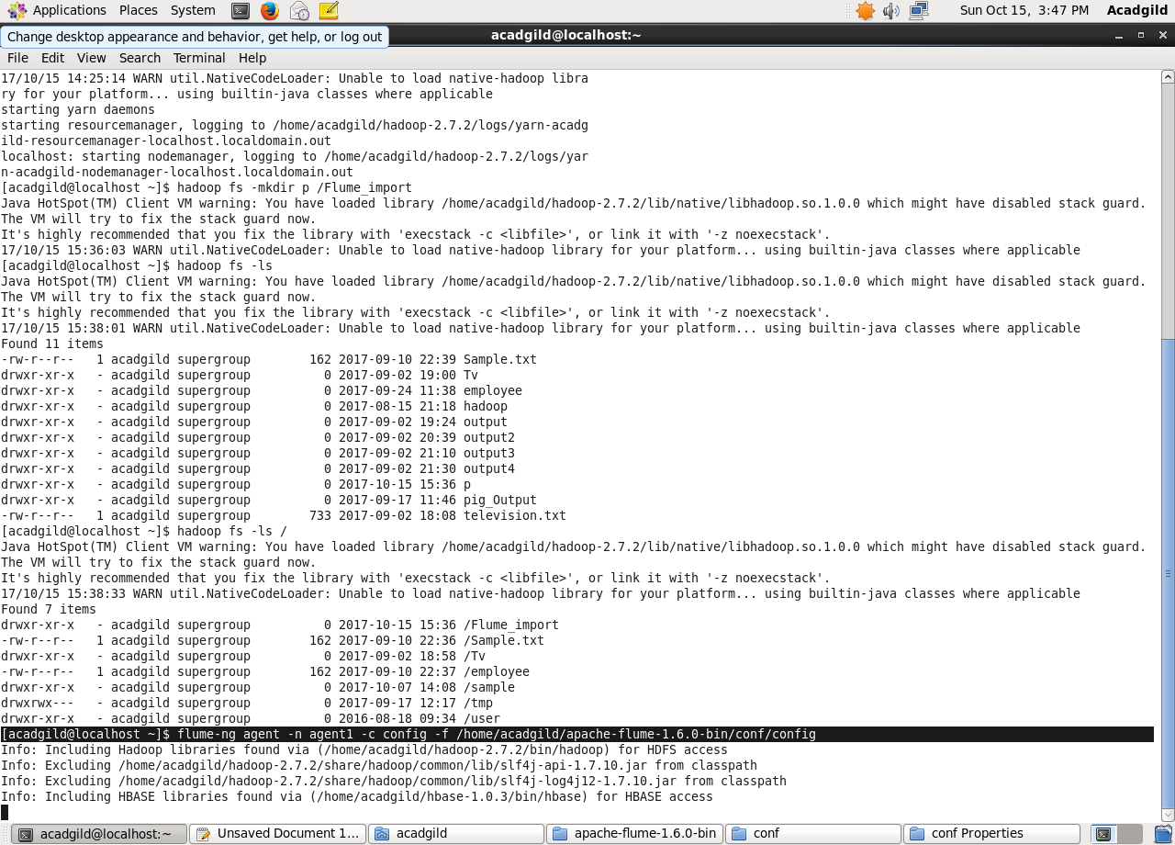

Listing the created directory and performing basic cat operation.

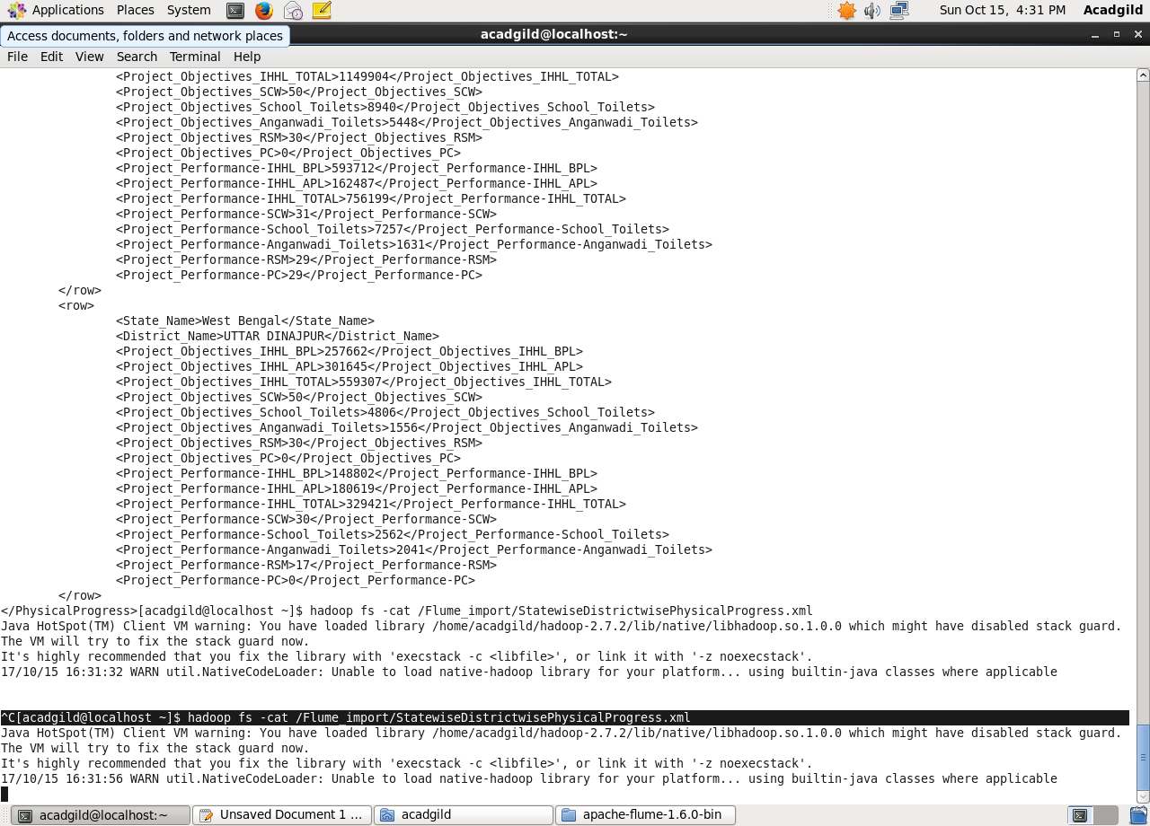

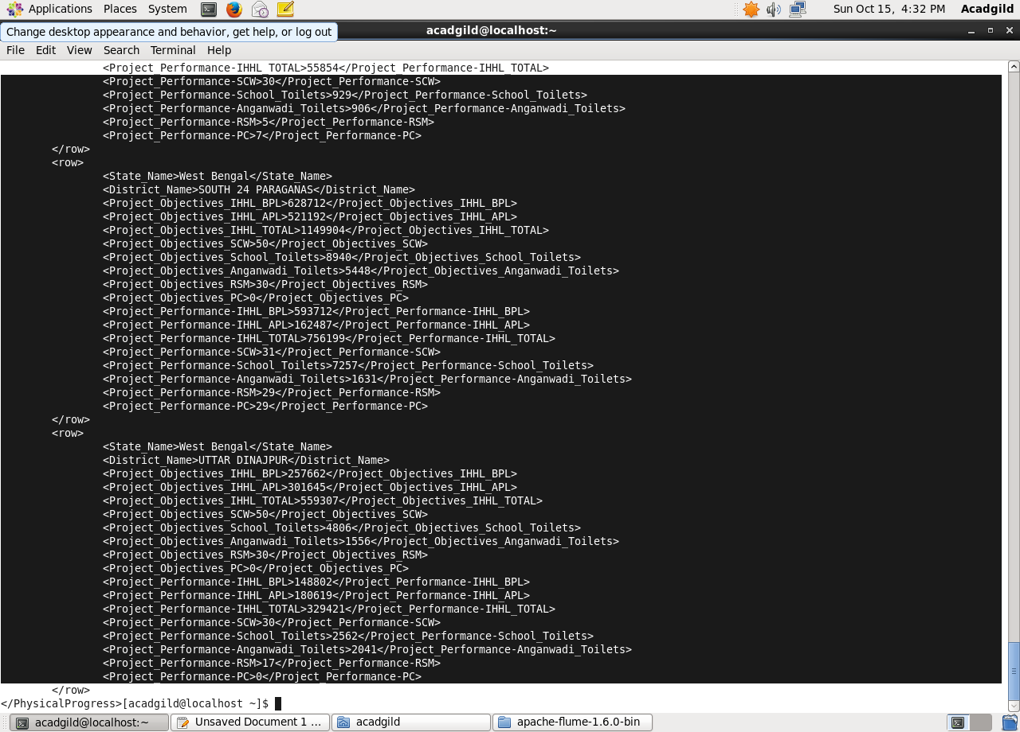

Here data is loaded from /flume project location which contains a XML file and in order to parse the xml file so that Pig can understand it.

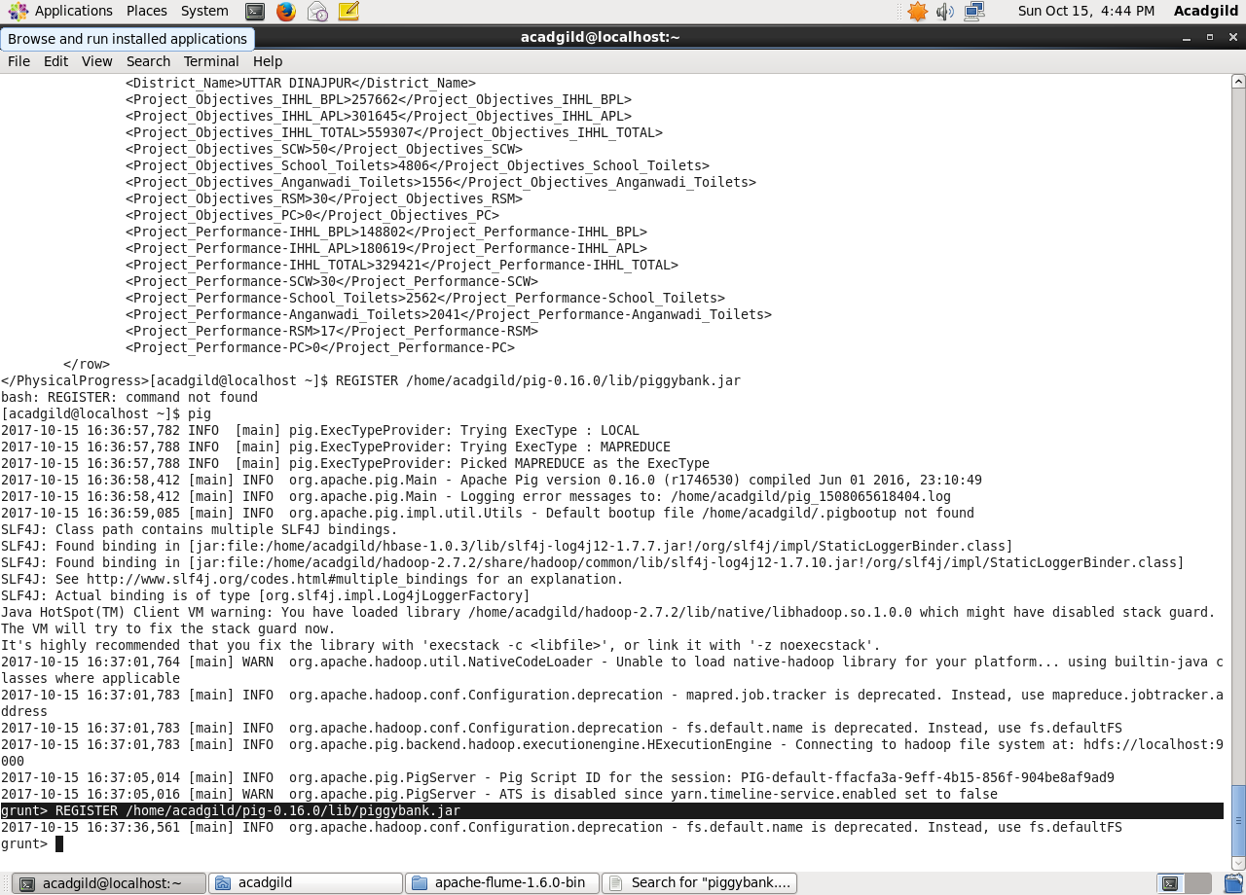

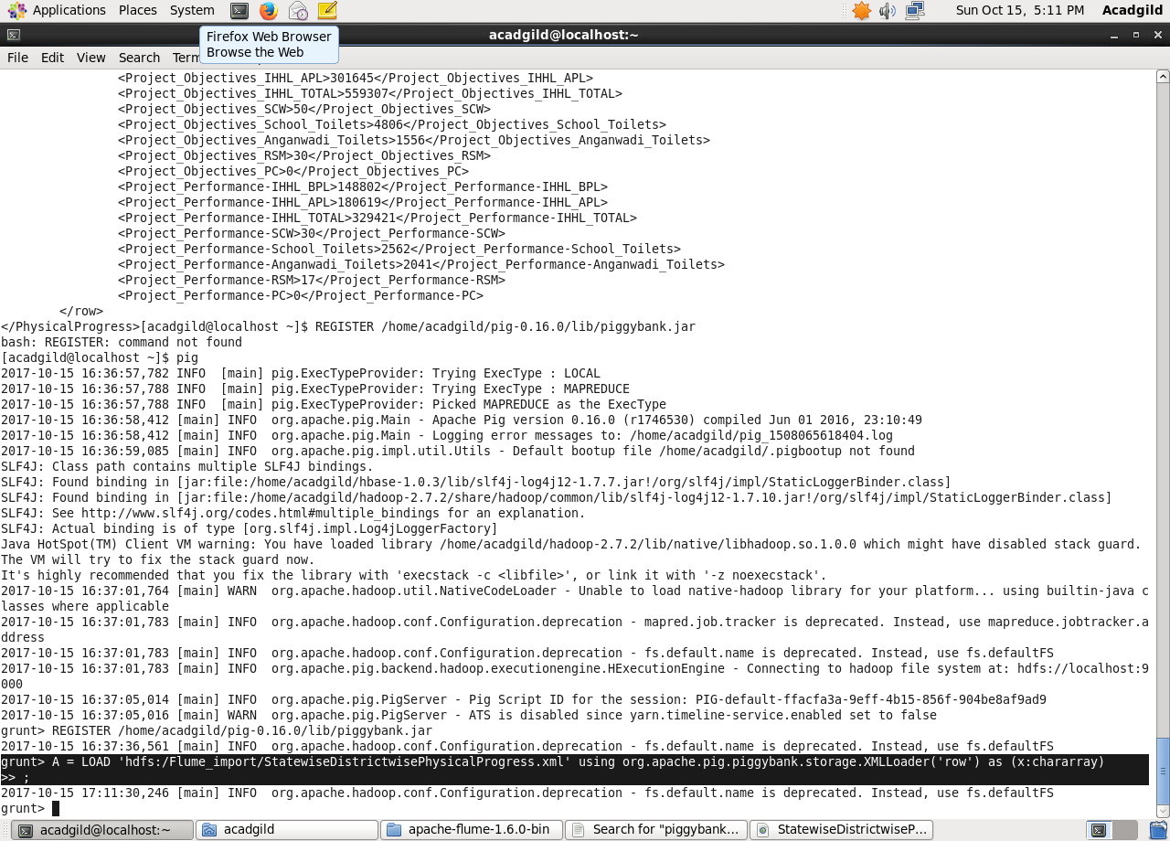

Using regex-function for capturing the values within tag and FLATTEN is used flattening the TUPLE.

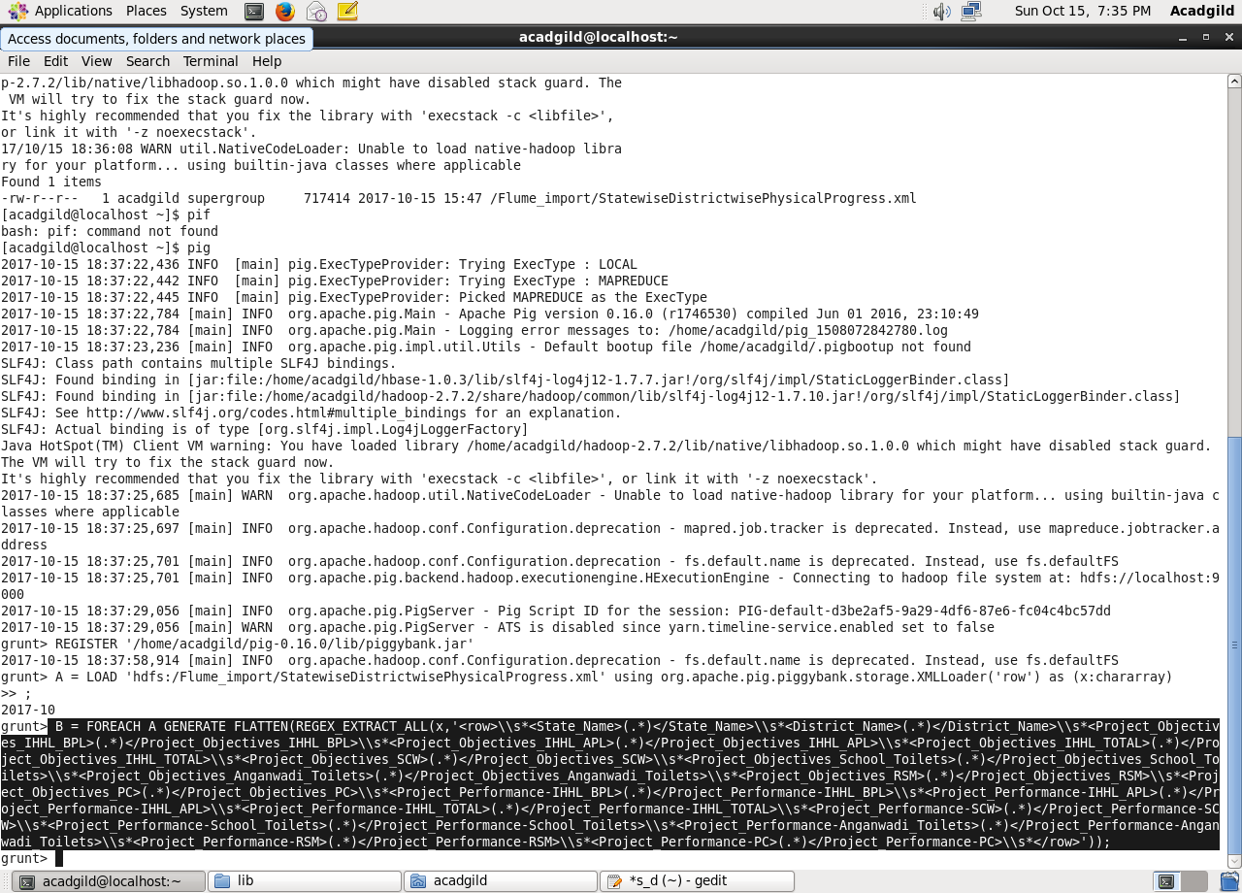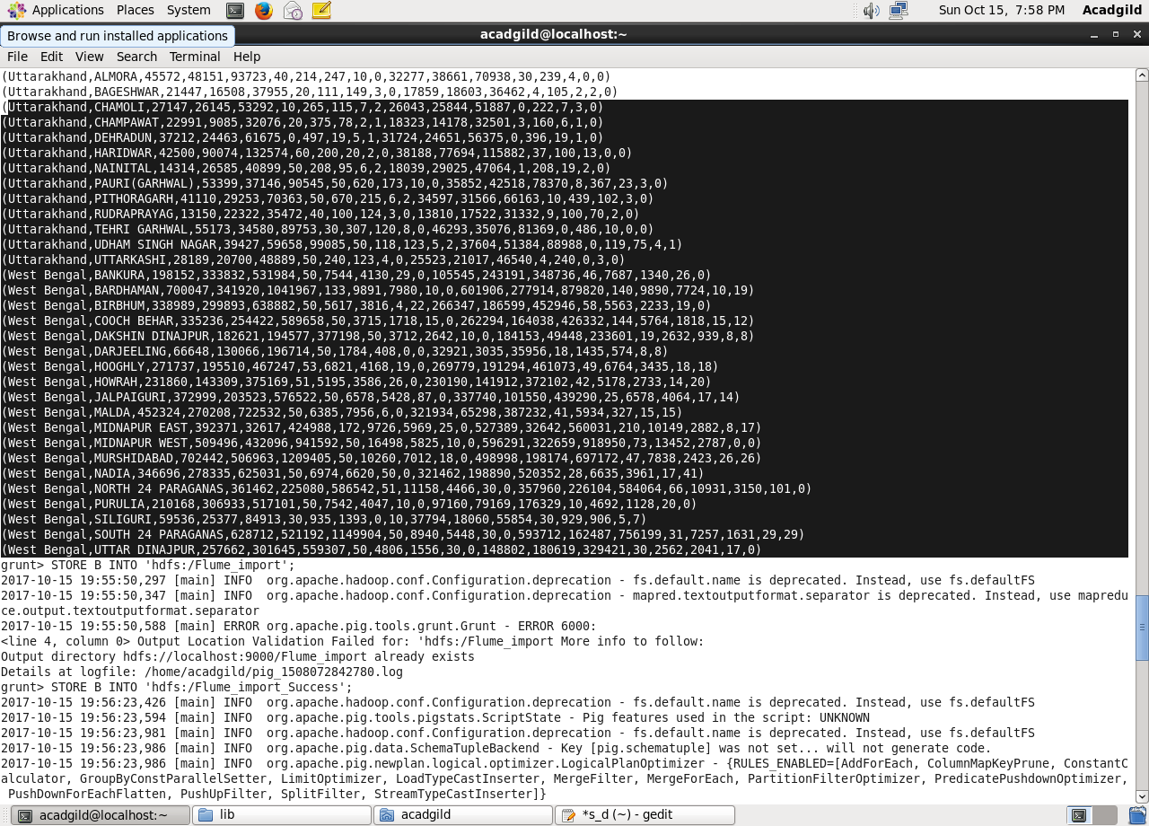

Storing the above results into HDFS for further analysis.

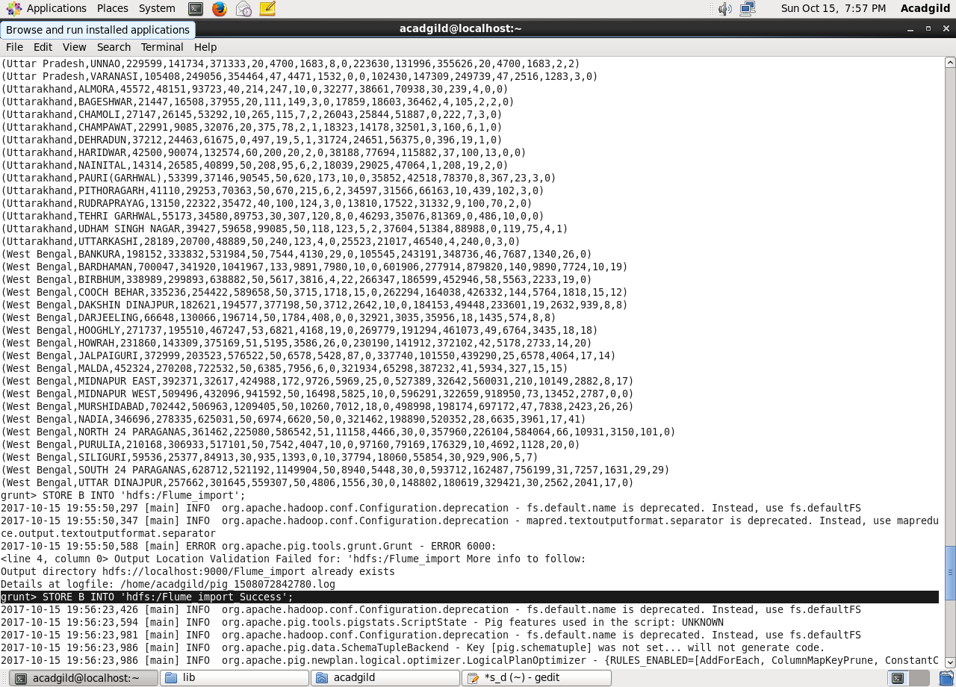

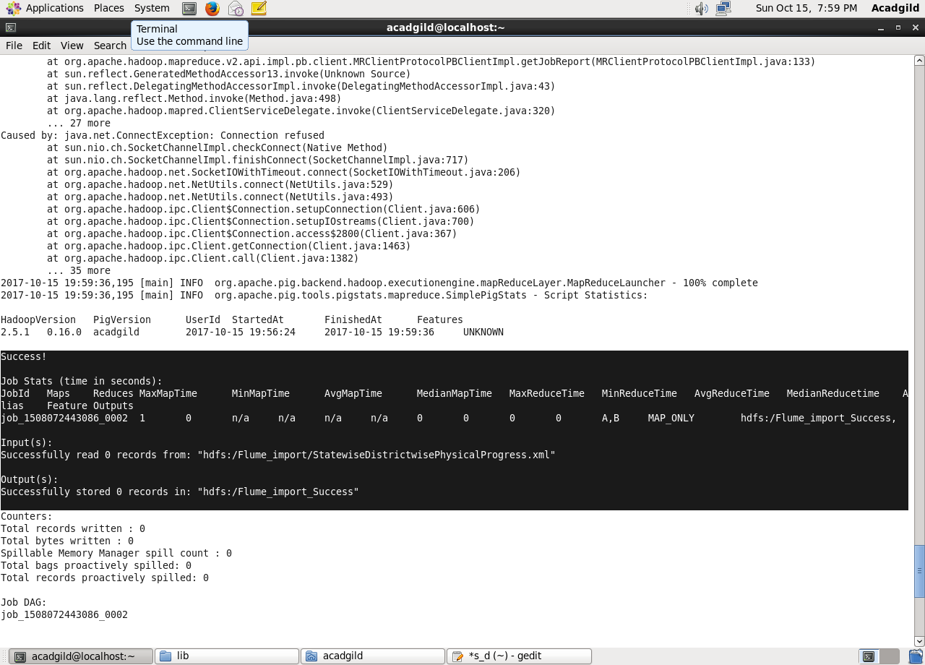

Here, we can see that data is successfully stored.

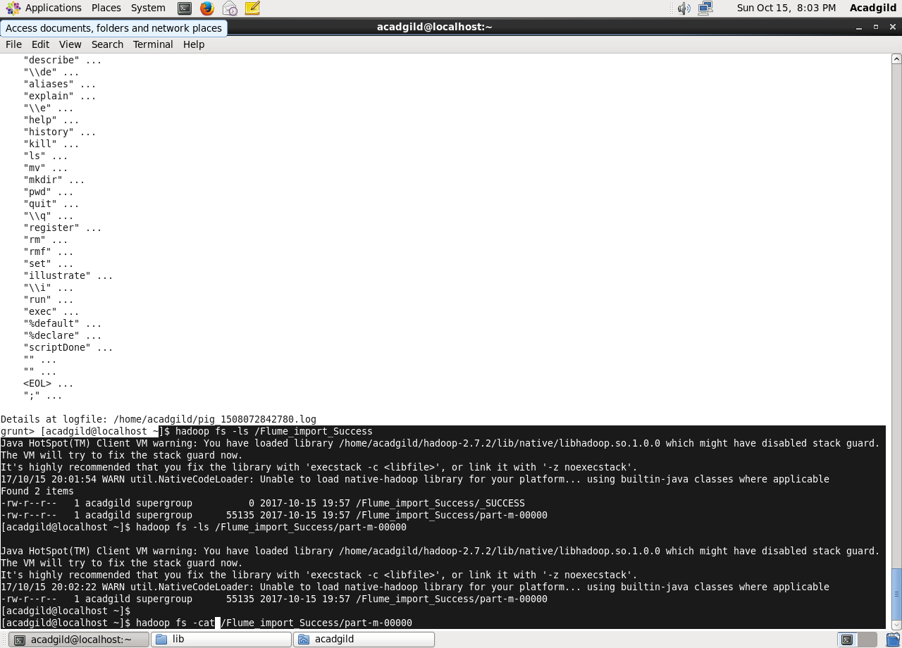

Using cat command we can see the stored data.

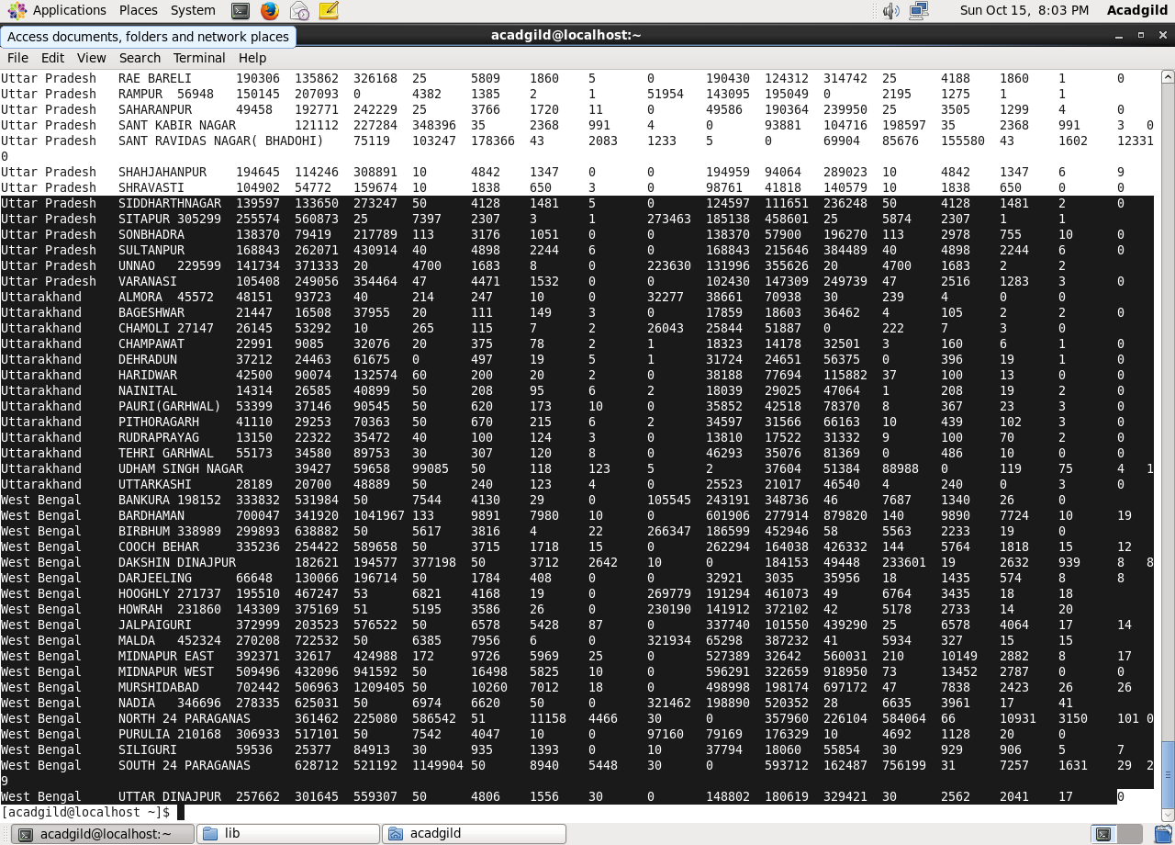

**Problem statement1**

1. Find out the districts who achieved 100 percent objective in BPL cards Export the results to mysql using sqoop .

Step1: loading the dataset

Step2: filtering the loaded data so as to get the districts who achieved 100 percent objective in BPL cards.

$10 is the project objective in BPL cards column

$2 is the project performance in BPL column

Comparing whether $10 i.e, project objectives in BPL have achieved 100 percent or not.

Step3: If achieved then generating $1 which is the district column

Step4: finally storing the results as StatewiseT1op

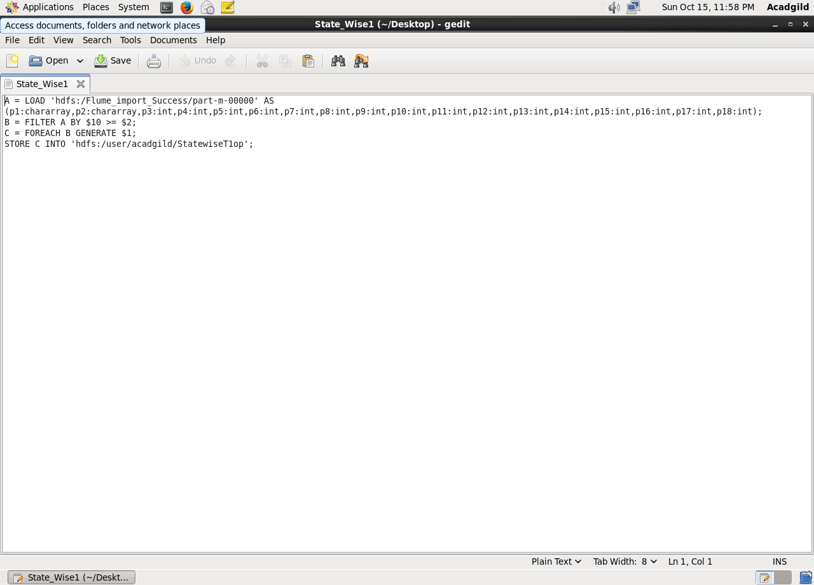

Running the above pigscript :

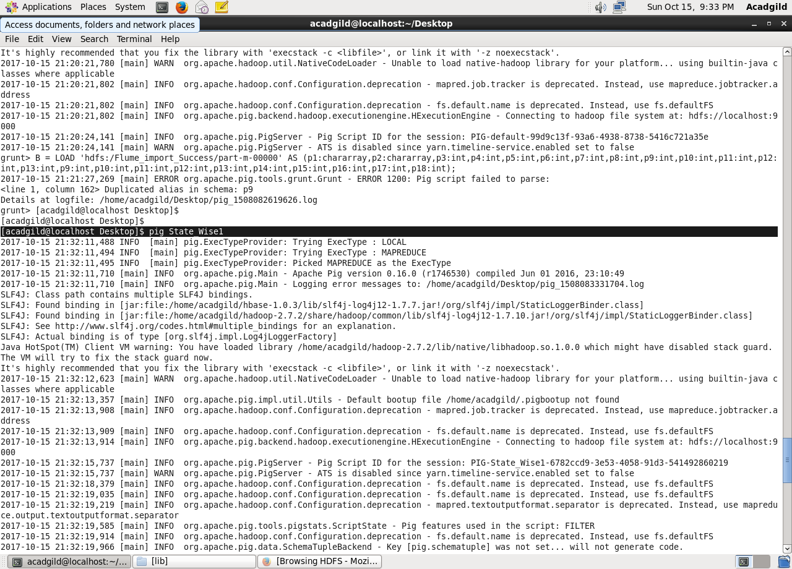

Here, we can see that job ran successfully.

Then, using cat command displaying the results.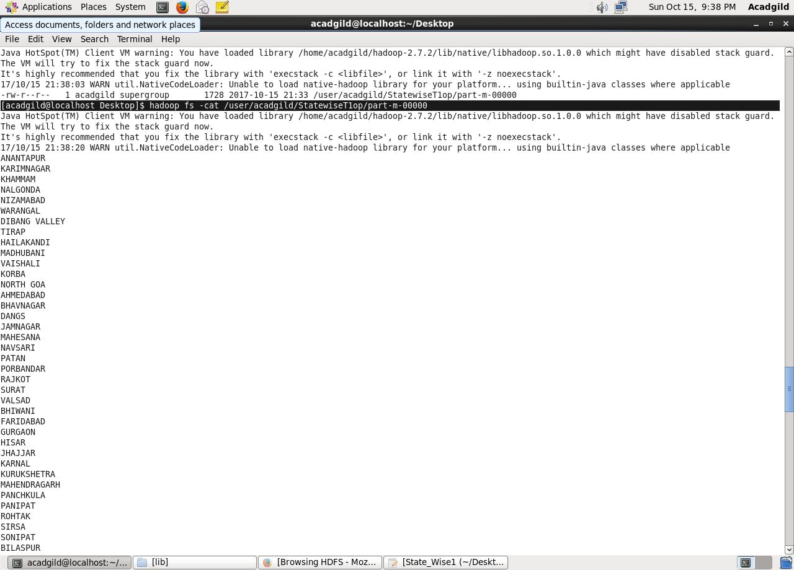

To export the result from pig using sqoop creating a table in mysql and inserting no values in the table so as to perform the export.

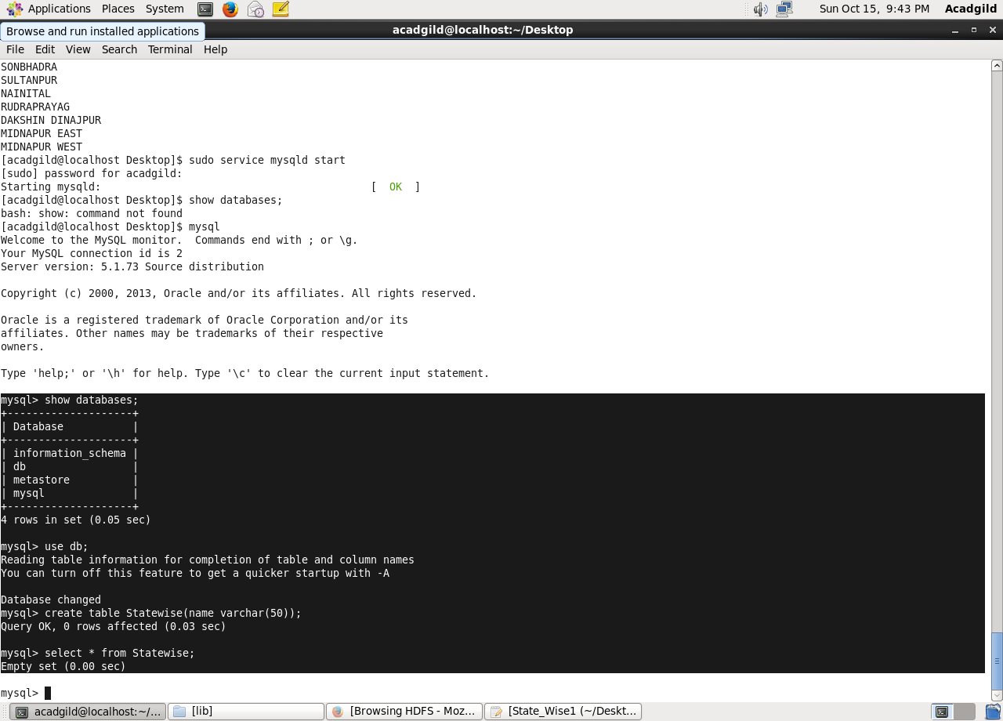

Below is the export command to export the records from pig to mysql

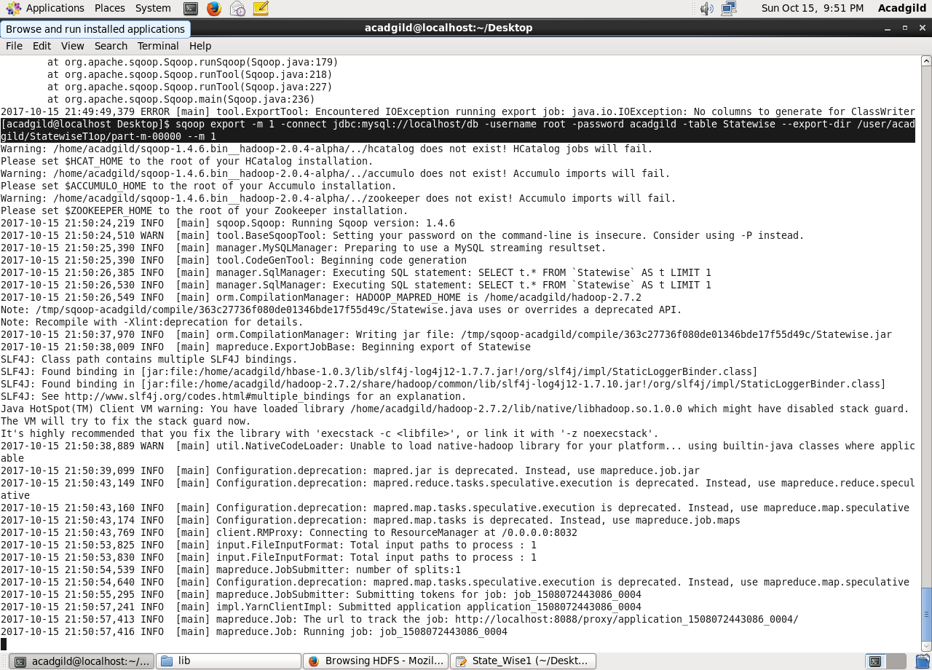

Now, if we perform the select operation on the empty created table it will show the exported data.

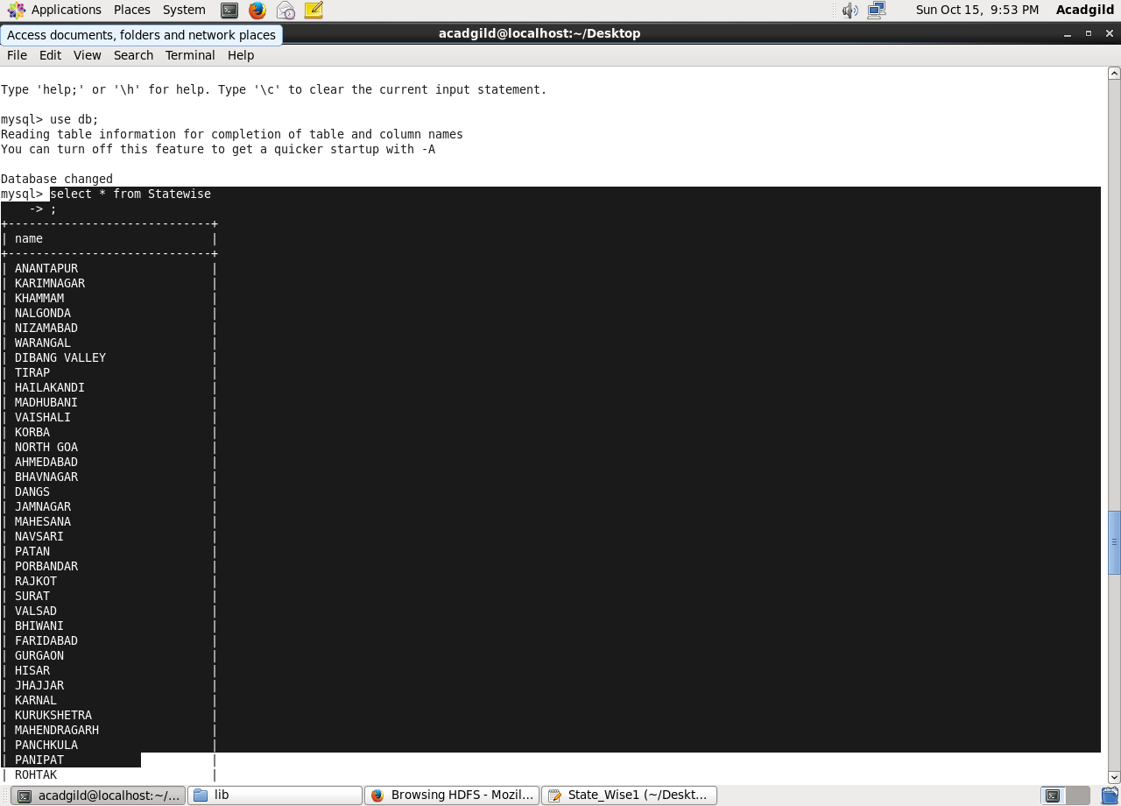

1. Write a Pig UDF to filter the districts which have reached 80% of objectives of BPL cards. Export the results to MySQL using Sqoop.

**Creating UDF:**

Adding the necessary Imports

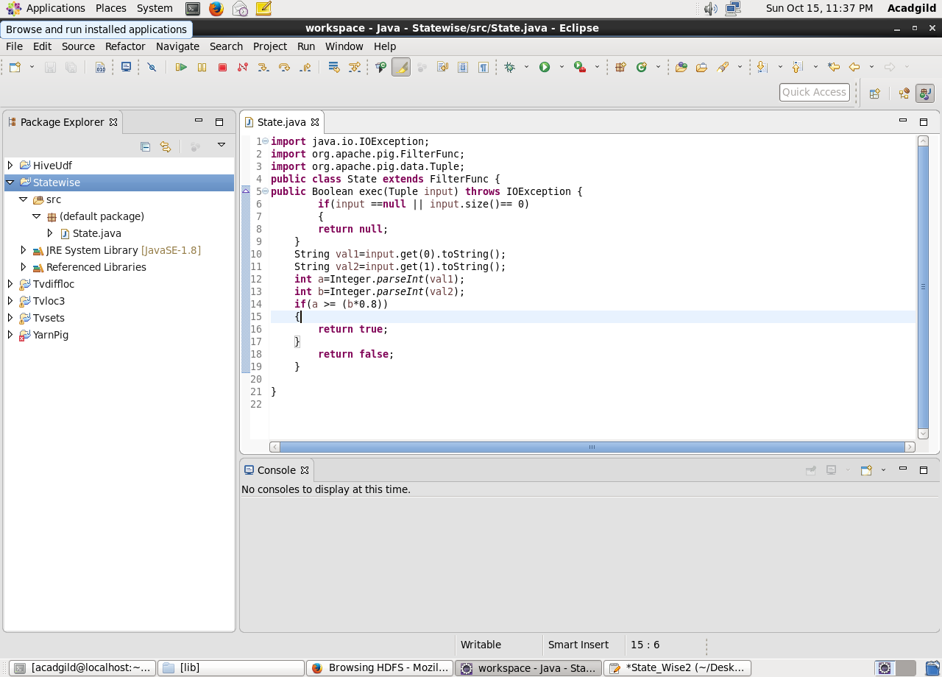

Firstly, registering the jar

Then, loading the data and the datatype and name of fields are defined.

**Filtering Districts that acheived 80%:**

Used a udf function “State” which filter the districts which have acheived less than 80%

**Generating District List:**

$1 is the district column. Here we are generating $1 so as to get the districts name which have reached 80% of objectives of BPL cards.

**Finally, Storing the result**

Data is stored into “StatewiseT2op” in Hdfs from which it will be exported to mysql.

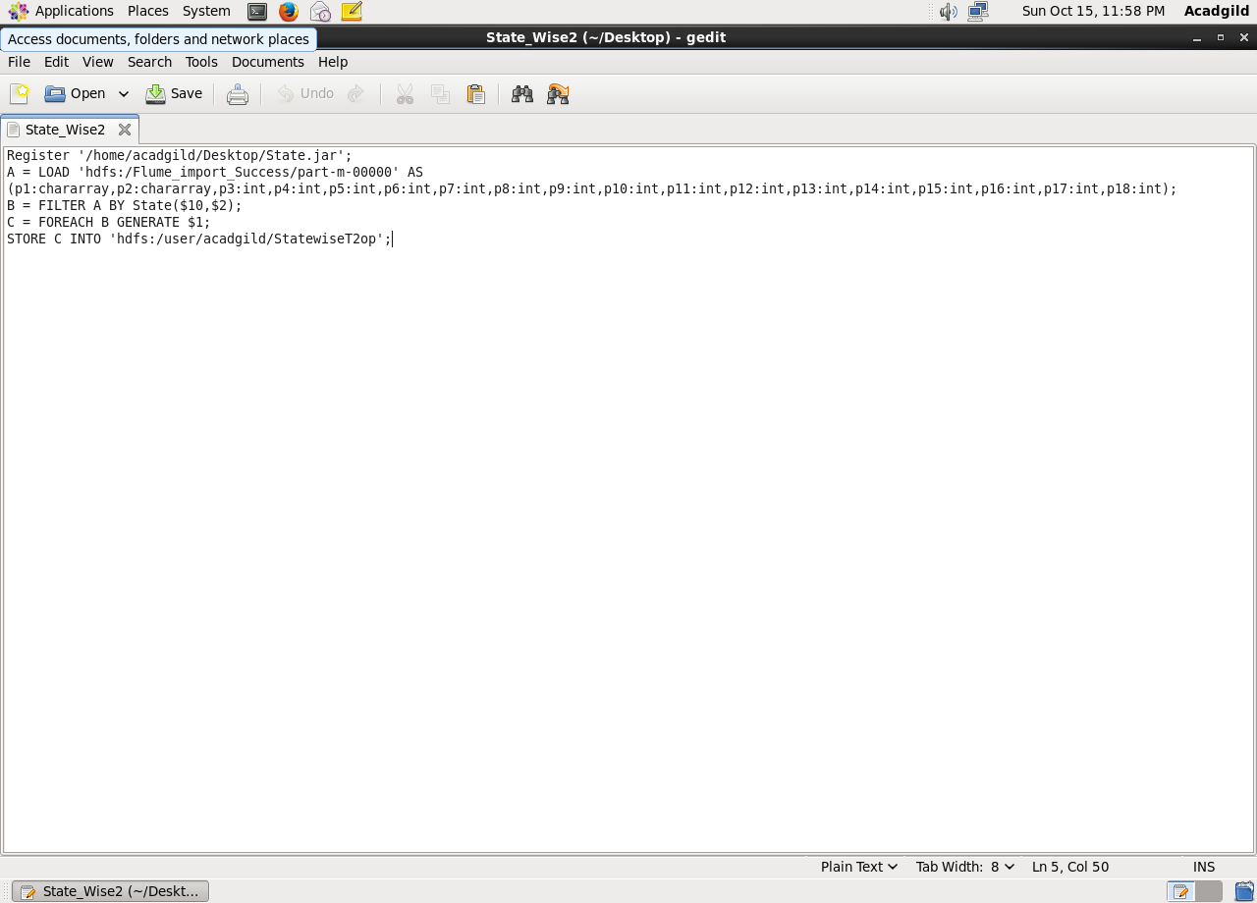

Running above pigscript:

$Pig State_Wise2

Listing it and then performing cat operation on it.

Cat command will display the stored output of the pig commands

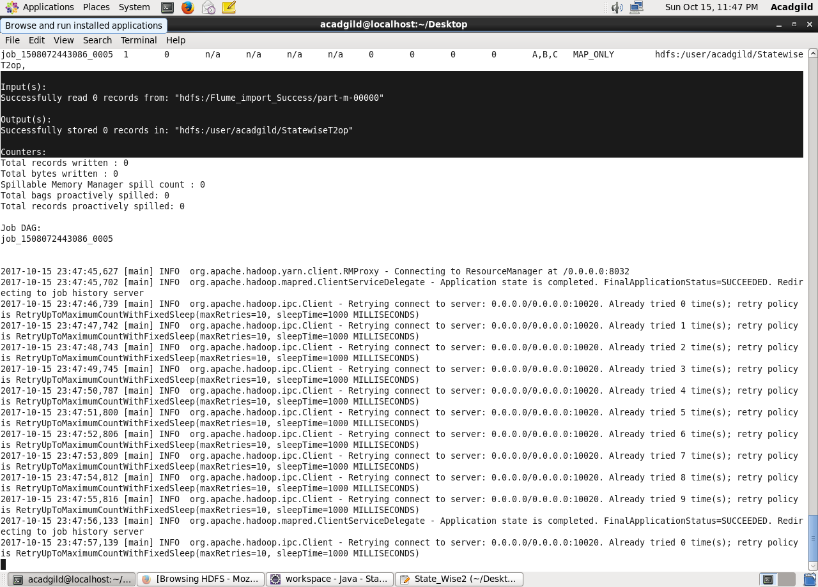

To export the result from pig to mysql using sqoop creating a table in mysql and inserting no values in the table so as to perform the export.

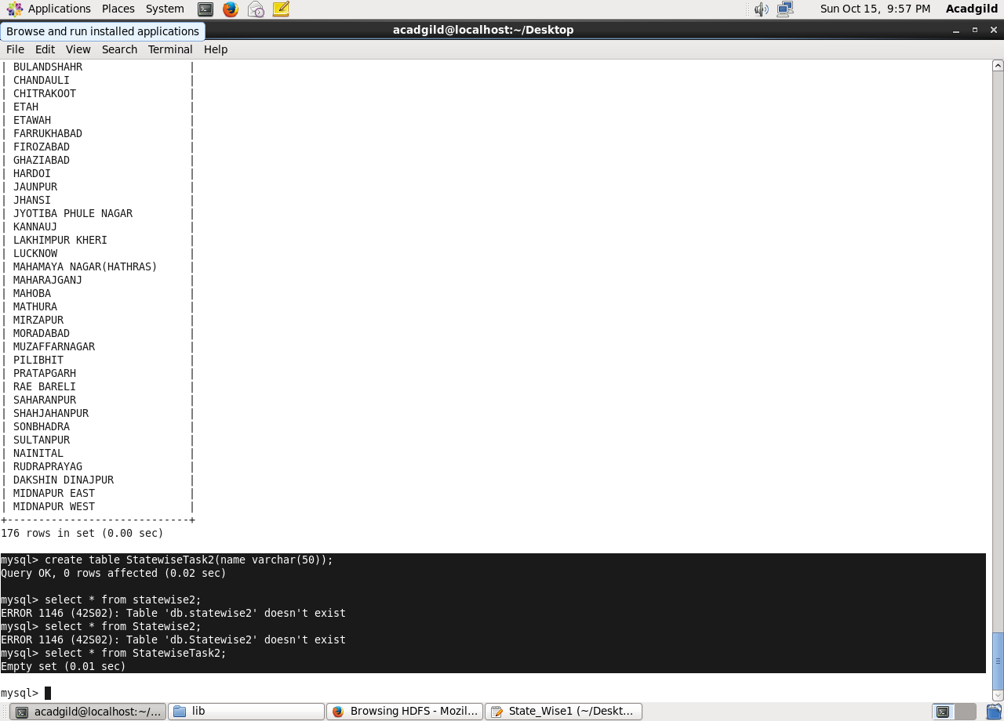

Below is the export command to perform export operation

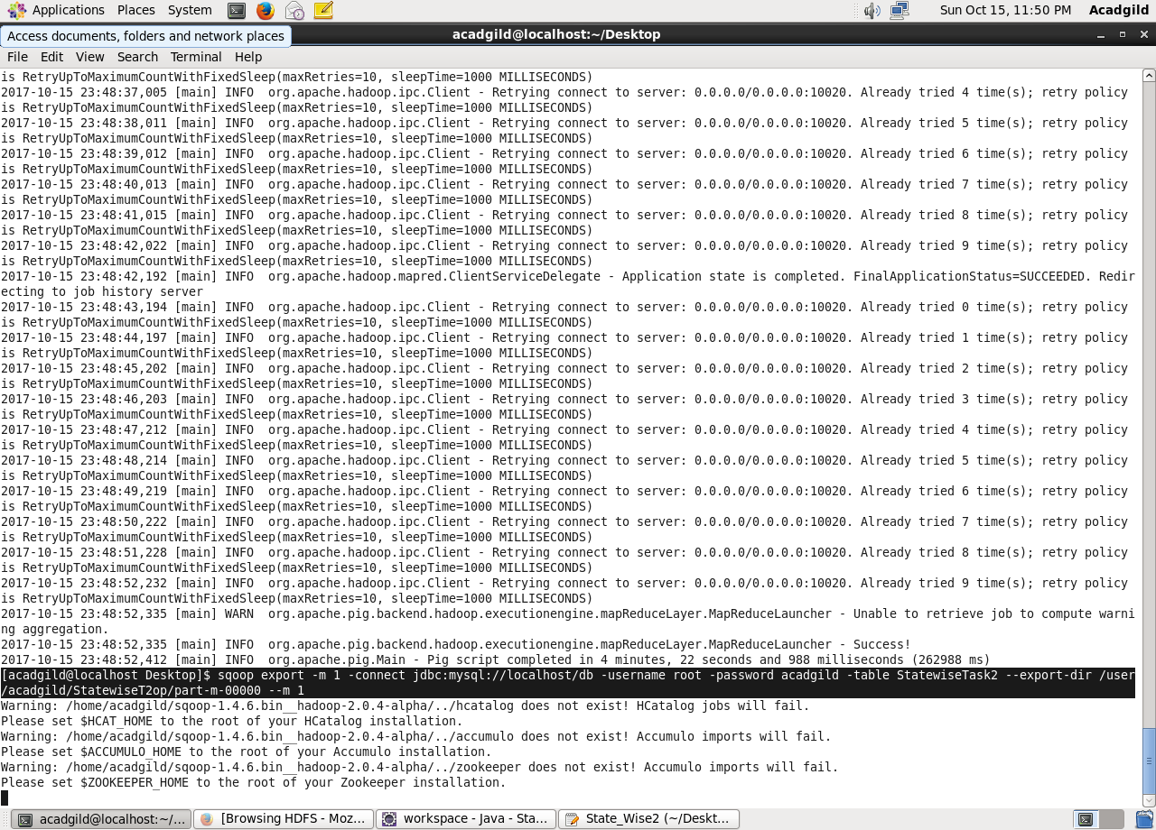

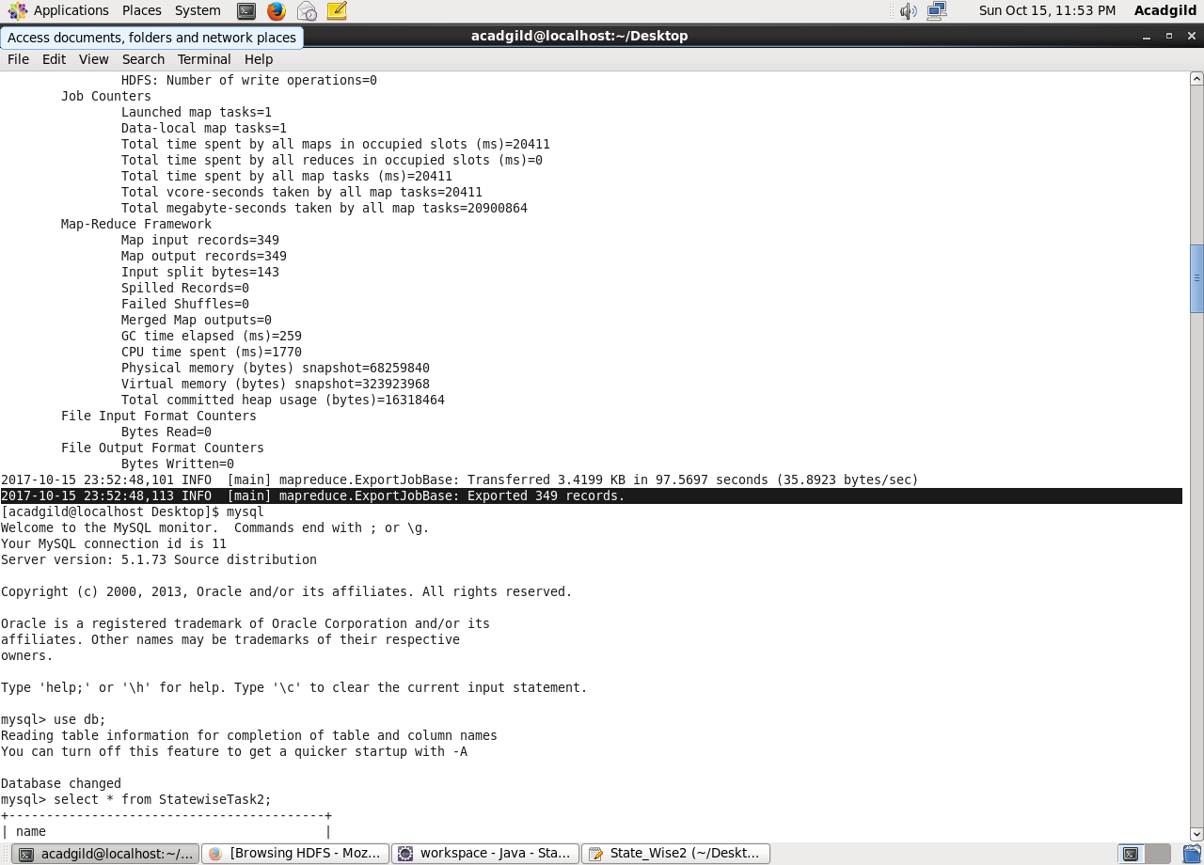

Here, we can see that successfully exported the records.

Using select command displaying the results.

